Name:_____________________________________ Date:__________________________

**Unit 1 Lesson 7**

**Do Now:** Determine whether each statement is *true* or *false*

|  |  |
| --- | --- |
|  |  |

**AIM: Properties**

1. Suzy draws the following picture to represent the sum. Ben looks at this picture from the opposite side of the table and says “*You drew*”. Explain why Ben might interpret the picture this way.

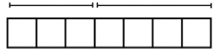

What property was illustrated above?______________________________________________________________

a + b =

Does this property work for any other operation? ____________________________________

1. Suzy adds more to her picture and says, “the picture now represents. Ben interprets this picture as .” Is he correct? Explain.

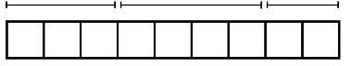

What property was illustrated above?______________________________________________________

a + (b +c ) =

Does this property work for any other operation? ____________________________________

For #3-6, determine which property makes the following two expressions equivalent. You can just label them with a **C** for Commutative Property and an **A** for Associative Property.

|  |  |  |  |
| --- | --- | --- | --- |
|  |  |  |  |

1. Given the expression  write an equivalent expression using the commutative property.
2. Given the expression  write an equivalent expression using the associative property.

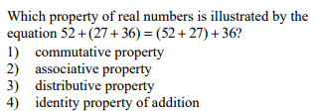

For #10-13, identify the property being illustrated using the following abbreviations

**A = Associate property**

**C = Commutative Property**

**D = Distributive**

**CLT = Combine Like Terms**

|  |  |  |  |  |  |  |  |  |  |  |  |  |  |  |  |  |
| --- | --- | --- | --- | --- | --- | --- | --- | --- | --- | --- | --- | --- | --- | --- | --- | --- |
|  | | |  |  |  | | --- | --- | --- | |  | 23 + 5*x* + 7*y* – *x* – *y* – 27 | Given Statement | |  | 23 – 27 + 5*x* – *x* + 7*y* – *y* | ______________ | |  | (23 – 27) + (5*x* – *x*) + (7*y* – *y*) | ______________ | |  | –4 + 4*x* + 6*y* | ______________ | | | |
| |  |  |  | | --- | --- | --- | |  | 3(*x* + 2) – 4*x* | Given Statement | |  | 3*x* + 6 – 4*x* | _________________ | |  | 3*x* – 4*x* + 6 | _________________ | |  | –*x* + 6 | _________________ | | | 1. State the properties being used in the mathematical proof of the algebraic equivalency of  and .     Given Statement  ______________  ______________  ______________ | | |
|  | |  |
|  | |  |
|  | |  |